Outputs :

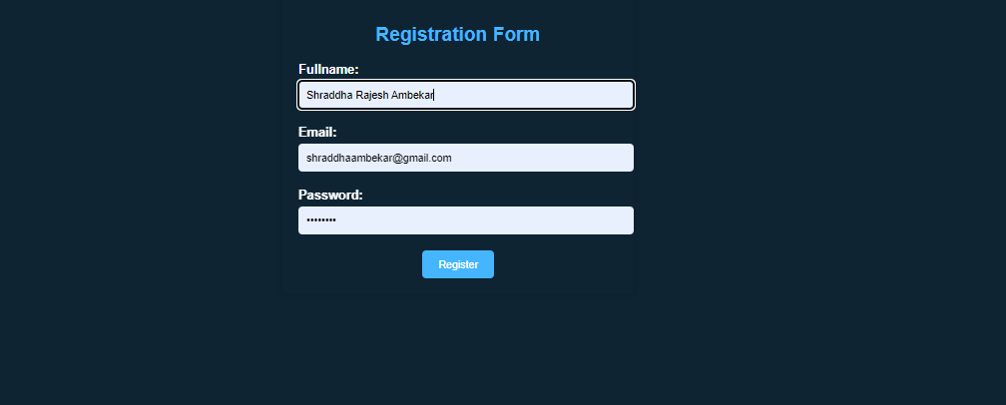

Fig : 1. <http://localhost:8080/registration> output

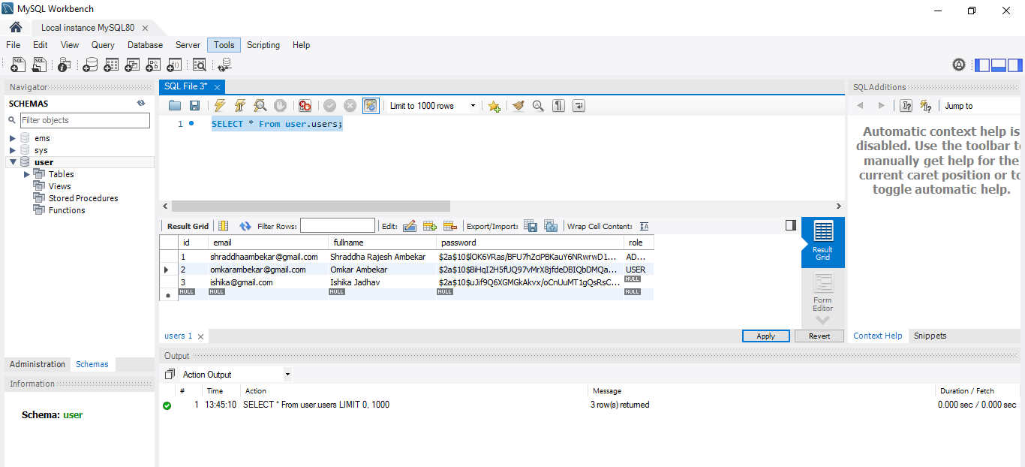

Fig : 2.Record added to Database.

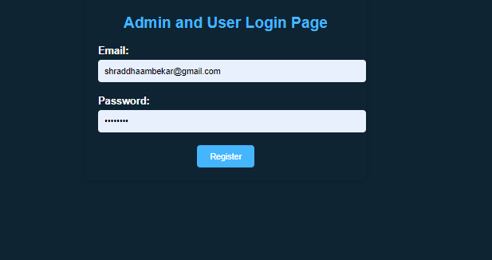

Fig : 3. <http://localhost:8080/login>



Fig: 4.Login successful

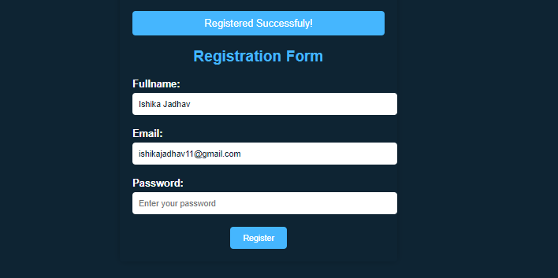

Fig:5.New Registration done

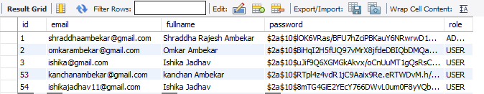

Fig: 6. All records in database